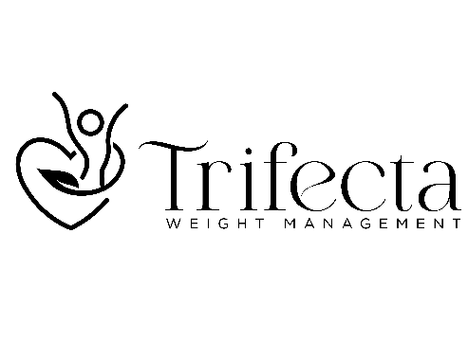
www.trifectaweightmanagement.com

Medical Nutritional therapy (Dietary Counseling)
This six-week program involves regular consultations with a registered dietician who will teach you how to make informed food choices to manage excess weight. The consultations consist of a review of your current diet to identify patterns that contribute to excess weight. The dietician will teach you how to incorporate nutritiously dense foods that keep you full longer.
Research shows that eating nutritiously dense foods result in greater satiety with benefit of lower calories consumed promoting weight reduction. Calorie reduction along with a diet that includes nutritiously dense foods reduces inflammation and burden of disease from excess weight.
Our registered dieticians specialize in weight management and adhere to the Canadian Obesity Guidelines.
Throughout the duration of the program, you will have access to medical consultations with Dr. Gardizi. We understand that managing weight is a long-term commitment. The ongoing medical consultations and access to our team of experts will help keep you on track with overall wellness goals.

Cost of the program:
$675.00 Plus HST

Plan Summary
- 6 Sessions (Initial 50-minute consultation followed by five 25-minute consultations)
- 3 Consultations with physician
- All sessions are done virtually.
- The cost of the program can be covered by most insurers.
- Receipts provided after each session.
- We offer flexible payment options.

To sign up, please send us an email: trifectaweightclinic@gmail.com and someone from the team will reach out to get you started on your wellness plan.

