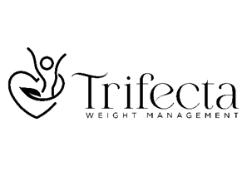

Website: [www.trifectaweightmanagement.com](http://www.trifectaweightmanagement.com)

**Movement: Personal trainer**

Our Movement Specialists provide guidance to simply help you move more! Our trainers understand that excess weight is a chronic medical condition. Your initial consultation will provide you with an understanding of your baseline activity level. They will create a movement plan that you will enjoy and sustain over the long run.

Irrespective of diet, regular moderate intensity exercise improves metabolic parameters by reducing waist circumference. This has significant benefit in reducing inflammation and cardio metabolic disease burden in the context of excess weight.

In addition, regular moderate intensity exercise – particularly resistance training – is imperative for those patients who are being treated for excess weight with medications. Some of the medications contribute to not only fat loss but muscle mass loss. Maintaining muscle mass as we age is critical and helps protect our bones and sustain vitality and well being. Our trainers utilize various kinds of exercises to strengthen muscles and correct posture. For example, for those who are not very active, the trainers help to introduce certain range of motion exercises. For others, the trainers teach exercises that use their own body weight (calisthenics) to help strengthen muscles. The goal is not to get anyone into a gym, but simply to incorporate more movement within your daily routine.

The aim of the program is to improve fitness, strength, and endurance by using exercises that you will enjoy. We hope that with the help of our exceptional trainers, your activity level will improve which will have profound positive impact on maintaining a healthy weight, improving mood and overall energy levels.

**Cost of Personal Training program:**

6 sessions (1 hour each) $675.00 plus HST

12 sessions (1 hour each) $1250.00 plus HST

***Monthly membership option available (2 sessions every month with cancellation anytime)***

**Plan Details**

* Free initial 15-minute consultation with a trainer to determine if you are both a good fit
* Training sessions can be done virtually or in person
* Receipts can be provided upon request